4/1/2024
Edward Paul Robinson
GNB Property
Finance SOP

Table of Contents
Clients can choose to use finance on AMC through 3 means: 2
Open Banking 2
Statement upload 2
Manually adding receipts and making payments 2
Open Banking: 2
Credits 4
Due/overdue receivables 5
Pre banked receipts 6
Bank Transfer 6
Map with a letting (deposit return) 7
Proceed as unallocated 8
Property receipts 8
Offer progression 9
Debits (Unallocated Payments) 10
Map the debits: 11
BACS and EFT to process 11
Paid to Landlords 12
Paid to Contractors 14
Payable to Tenant 15
Deposits 16
Agency commission transferred 17

Clients can choose to use finance on AMC through 3 means:

Open Banking

Statement upload

Manually adding receipts and making payments

The most recommended approach is to set up open banking. We are integration go cardless which provided open banking facility using which client can connect their bank account and import statements

Open Banking:

Install plugin on CRM to enable open banking. This can be done by the below steps:

CRM> Customer Story> AMC Settings> Manage Plugins> Enable open banking

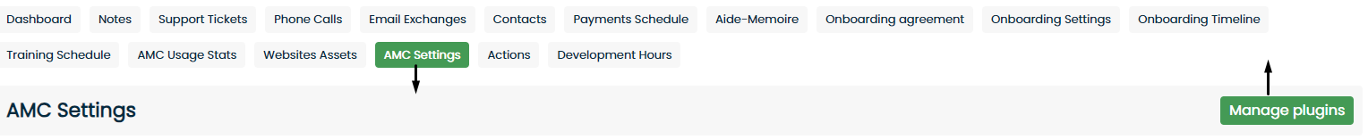

AMC> Finance module> Bank accounts> click on the plug icon> Connect the clients bank account> Provided bank details and login using bank app or OTP

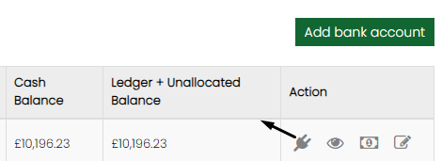

Note: There are few banks which does not support open banking for now

Once the set up is complete the client can import their statement from AMC by doing the below steps:

AMC> Finance module> Bank Statement> Import statement> select date range> import

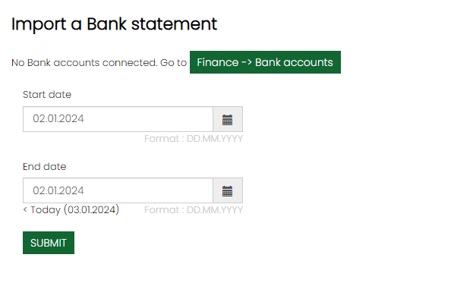

Note: The current day cannot be chosen as the day is not complete as of yet and it helps us prevent missing any payments made on that day

Once the statement is imported you can view the entries by clicking the eye icon. The amount is divided in two sections which are unallocated and allocated and there are two categories i.e. debits and credits.
By default all the payments will be under unallocated and will be visible in the bank account balance as ledger + unallocated

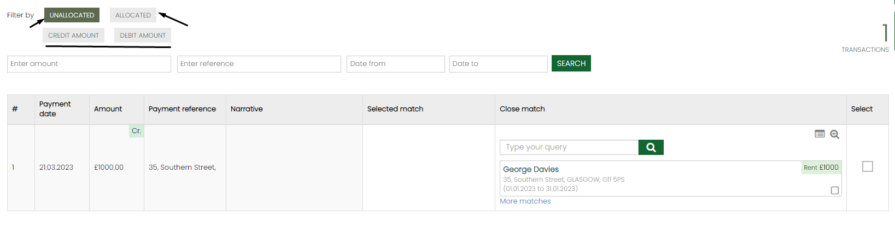

Credit and Debits are separated as unallocated receipts and payments. Credit are always allocated and debits are mapped on the system.

The system will not map any transaction automatically as there is room for error, hence AMC will give the close match based on payment reference, amount, and payment date out of which the most accurate match would be if the bank reference number for tenancy is added and if the payment is received with the same reference.

Credits

There are multiple ways a client can receive money to their account.

- Due/overdue receivables
- Pre banked receipts like cash card or cheque
- Letting deposit return
- Proceeding as unallocated
- Property receipt
- Offer progression – rent, holding deposit & deposit
- Bank transfer

There are multiple ways to allocate the transaction:

- Advance search 1
- Advance search 2
- Checkbox – rent and deposit
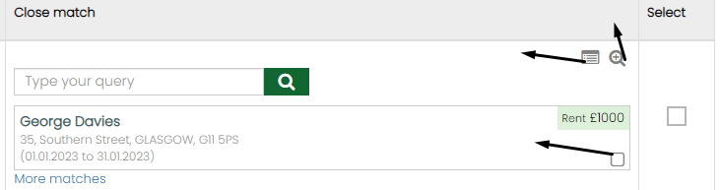

Due/overdue receivables

On the statement, once imported you will have a check box beside the transaction under unallocated. You can search for the letting if it does not bring your close match automatically. If the amount received matches the amount in the particular transaction then the system would allow you to allocate it. If the amount exceeds the amount received then it would open an option for multiple allocation using which you can allocate excess amount to the different letting or period that the amount belongs to
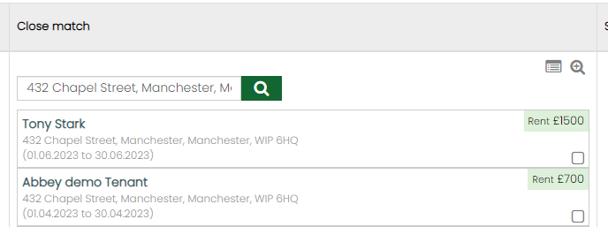
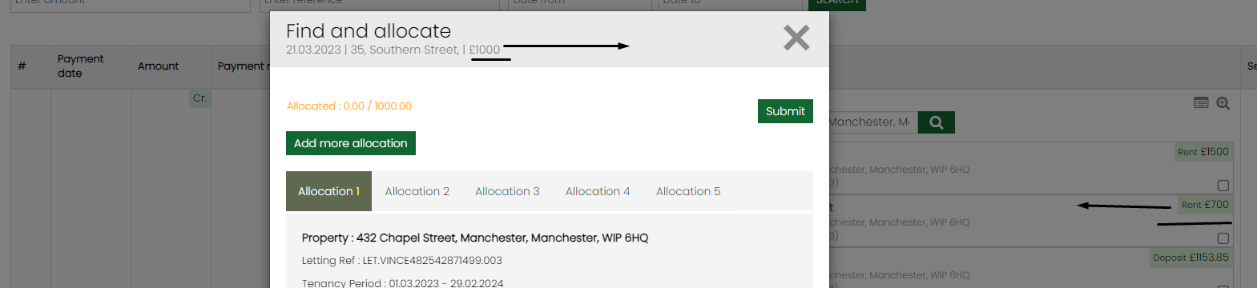

Note: The system will not allow you to submit the allocation unless the entire amount is allocated

Pre banked receipts

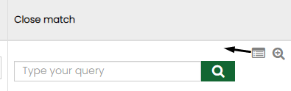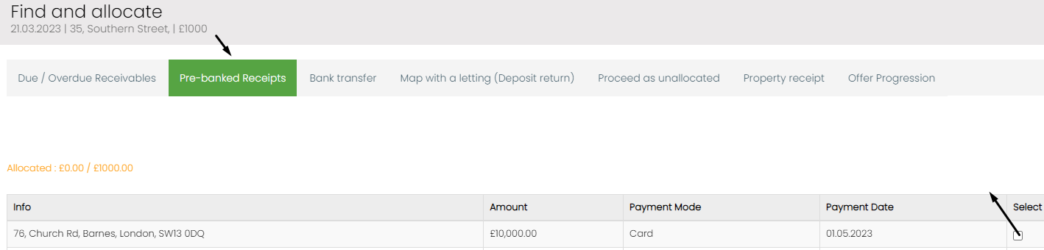

Click on the advance search option and choose pre banked receipts> you will find your card, cash and cheque transactions which you have received on the system and not cleared on the bank> Choose the payment and allocate it to the particular transaction

Bank Transfer

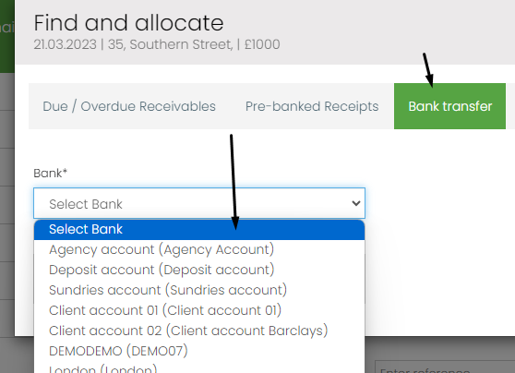

Money movement from one bank account to another. You will be able to map any amount that you have received to the source account the money came from. You will be select the destination bank the amount needs to be debit from and allocate the transaction. Once done you will see that the money gets debited from the source account selected and added to the client account

Map with a letting (deposit return)

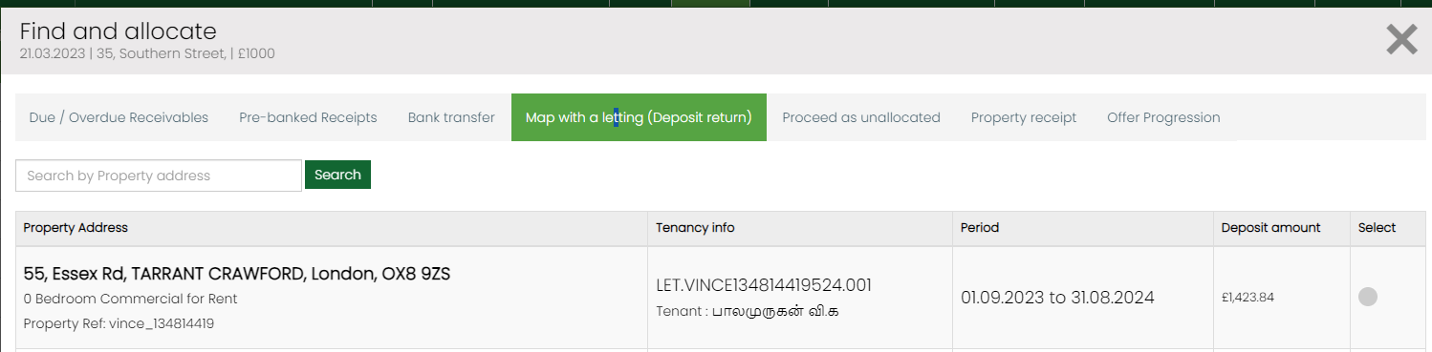

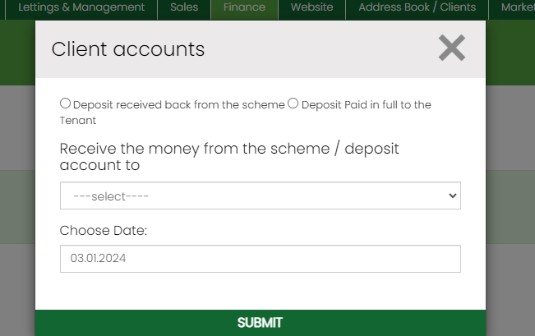

Click on the advance search option and choose Map letting with deposit return. This option will allow you to return a deposit to the tenant which has been collected and transferred to deposit scheme. You can either return the entire amount to the tenant or bring back the deposit back from the scheme to handle disputes.

Proceed as unallocated

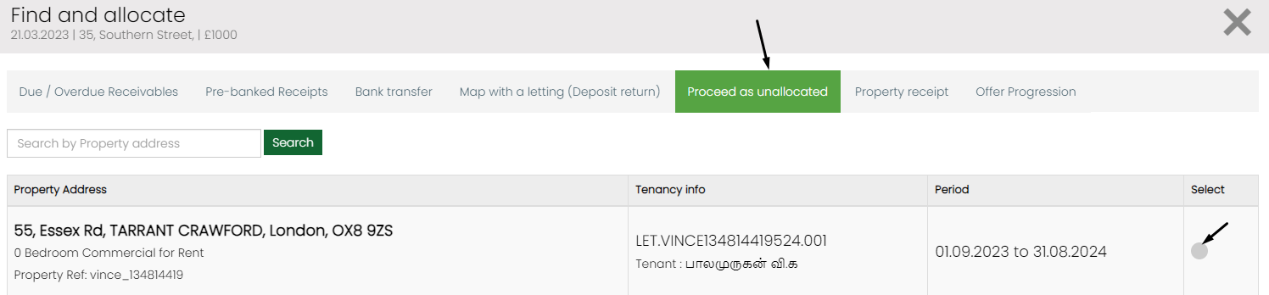

This will allow you to allocate the cash received as unallocated to a letting. This can then be allocated from inside the tenant statement

Property receipts

This will allow you to ad a receipt of money given by the landlord to the particular property. This will then reflect as an income in the landlord statement.

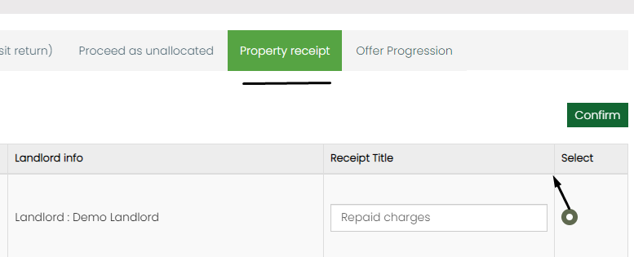

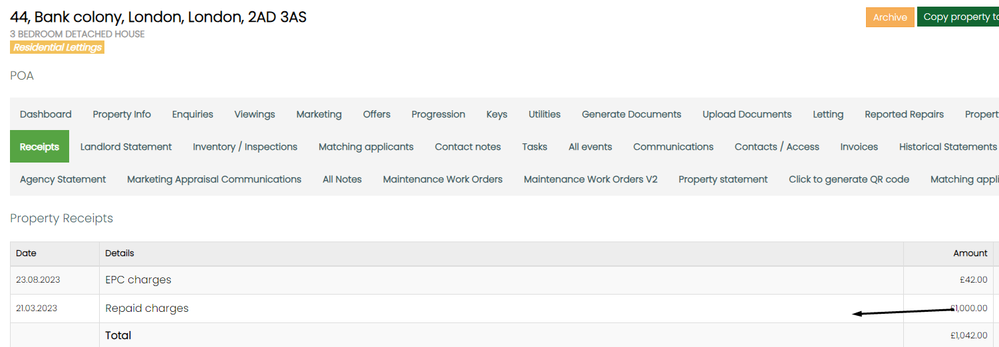

Offer progression

If you have an offer added to a property this option will allow you to received the rent, rent & deposit together or the holding deposit for the offer added. You can either search by the property or using the applicants name which will then allow you to choose the relevant offer to which it needs to be allocated towards.
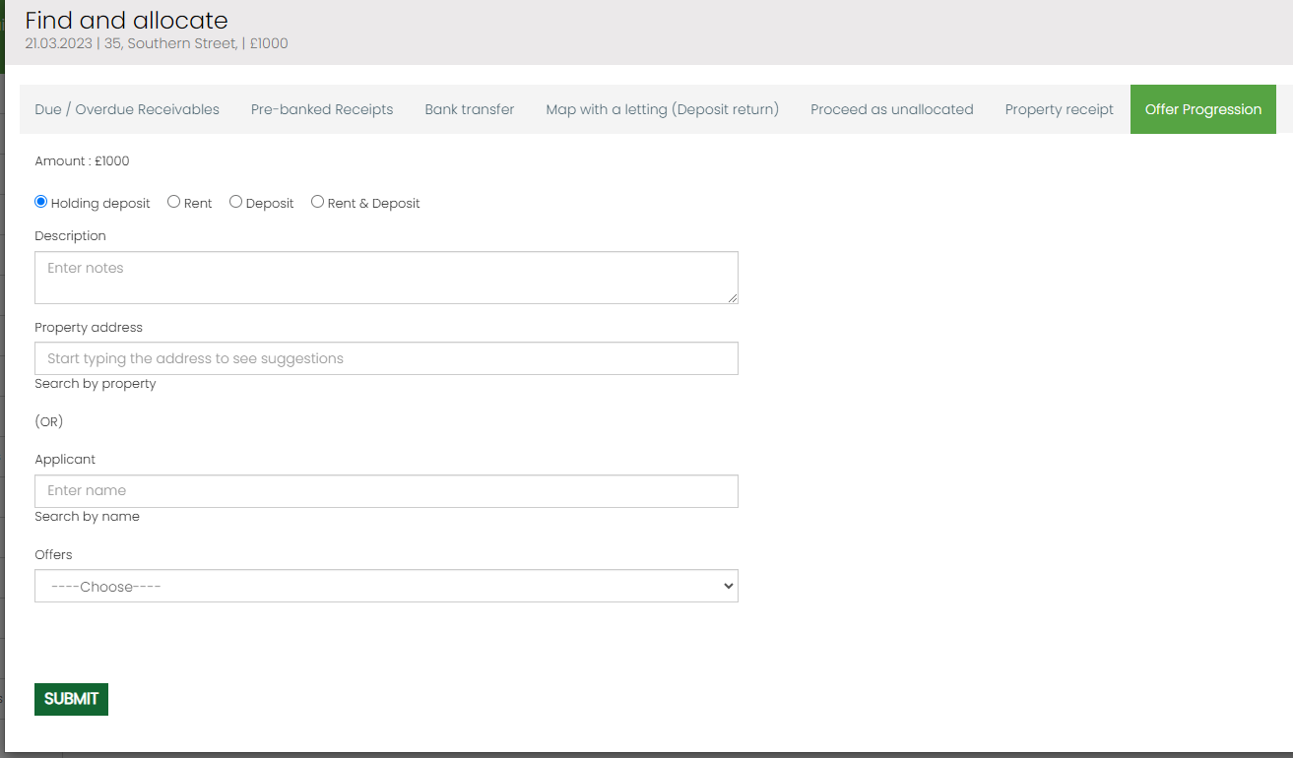

We have introduced two new options that will allow you to proceed with the excess amount as unallocated or allocate it towards future rents

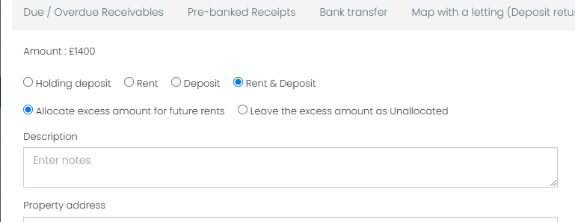

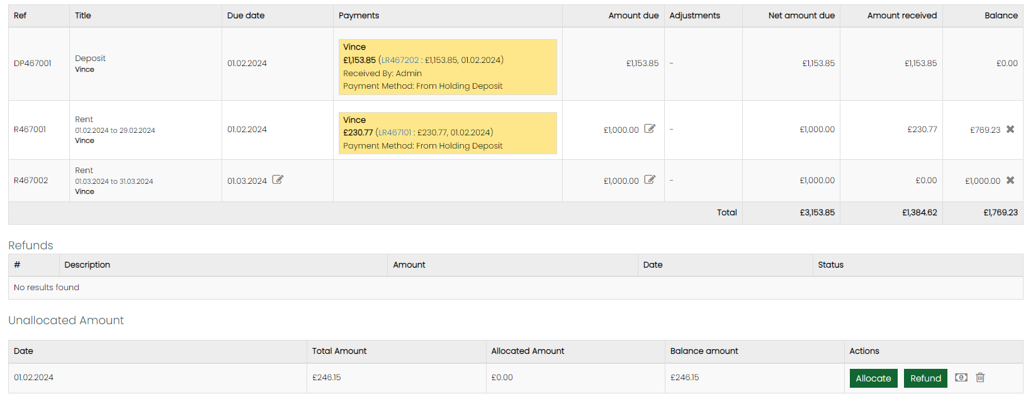

Debits (Unallocated Payments)

Any transaction that has been paid out of the account is part of debits. We will advising the client to pay out there transactions and map them from unallocated payments or bank statement.

They are Payables to Landlord, Contractor, Office expenses, Bank transfers, payables to tenants, Paid to deposit scheme, agency commissions transferred.

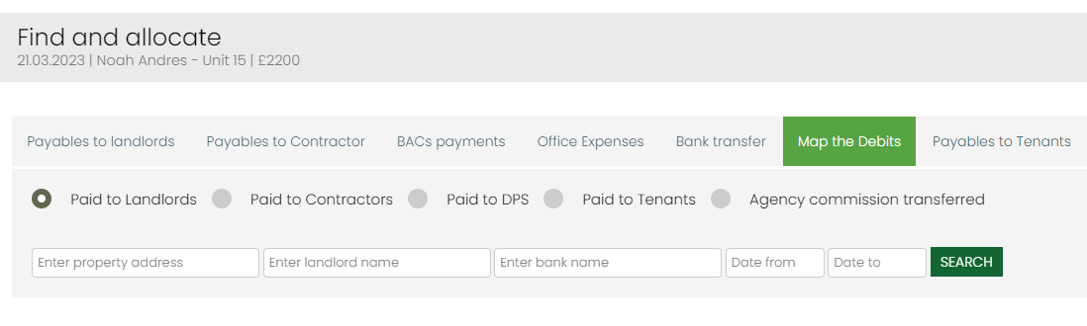
The options available will be limited to the following in the near future:

- Map the debits
- Bank Transfer
- Office expense

Map the debits:

- Paid to landlords
- Paid to contractors
- Paid to deposit scheme
- Paid to tenants
- Commission transferred to agency

The main thing to note here is to check with the client about their current payment cycle and suggest workflow accordingly.

BACS and EFT to process

What is BACS?

BACS stands for Bankers' Automated Clearing System. It's a regulated payment system run by Bacs Payment Schemes Limited (now Pay.UK) and is one of the most common ways that money is sent and received from bank to bank

EFT (electronic fund transfer) is used to move money from one account to another. The transaction is completed electronically

To avail this feature we need to ensure that the clients have added bank details for all their contacts. Each bank will have their own BACS format. We have most of the banks BACS format but please ensure to check with the client the format in which they upload BACS. Once they generate BCAS through our system they will get a .txt file which can then be uploaded to the clients bank through net banking.

Note that this can be used for landlords, contractors or tenants. But ensure that you generate BACS for landlord followed by contractor.

Paid to Landlords

We need to identify how the client is working at the moment to figure out if the have single landlord with multiple properties, multiple landlords for single property, If they send use consolidated landlord statements and enable features on AMC as per the workflow.

If agency manages property with landlord who has multiple properties then we need to enable Payable to landlord V2 and consolidated statement. This can be done by raising a ticket. Once done in scenarios where this applies once you click on pay you will see an option to pay multiple properties together.

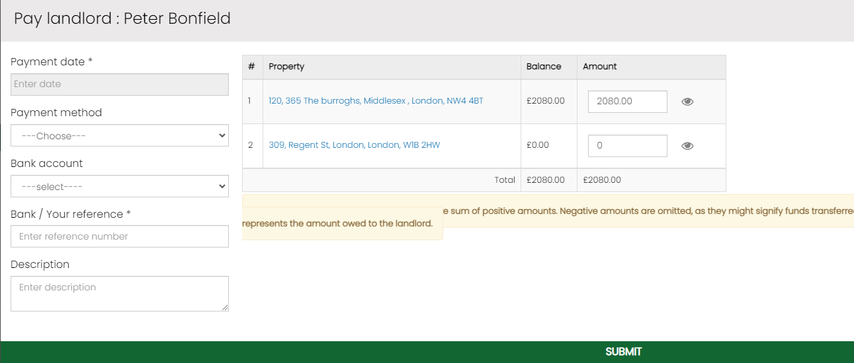

The balance shown is the amount that is available in the property that can be transferred (Positive property balance). If there are any negative amount you can click on the amount that allocate

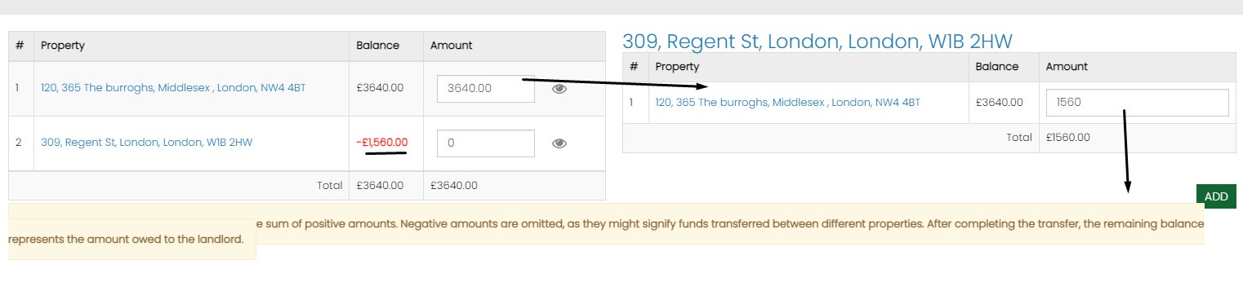

If there are multiple landlords for a single property the enable the plugin landlord split up payments under manage plugin and configure the split percentage under the property
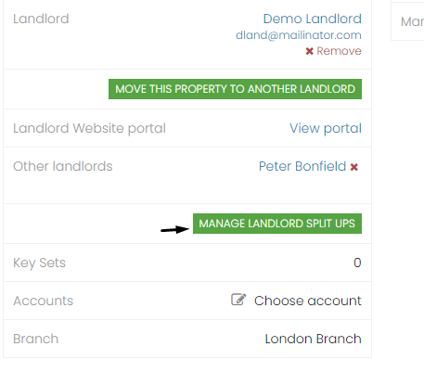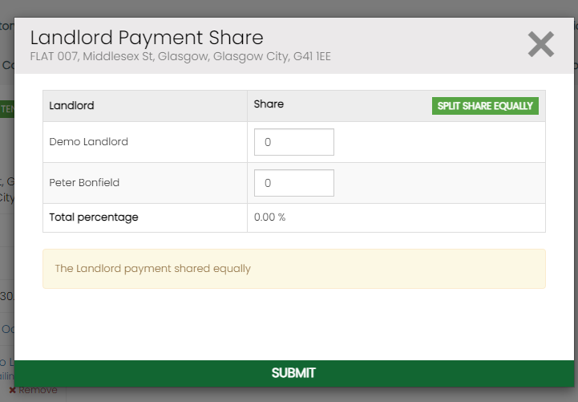

The client can go to payable to landlord, tenant or contractor and check the box under EFT

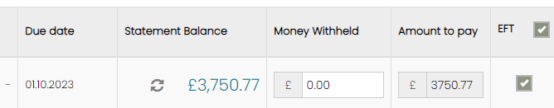

This will get added to EFT to process under finance module. Once all the payments are added to EFT to process section ask the client to double check and remove any transactions that are not required to be part of it by clicking the ‘x’ mark and make payment and generate BACS.

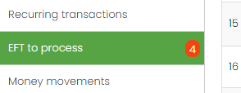

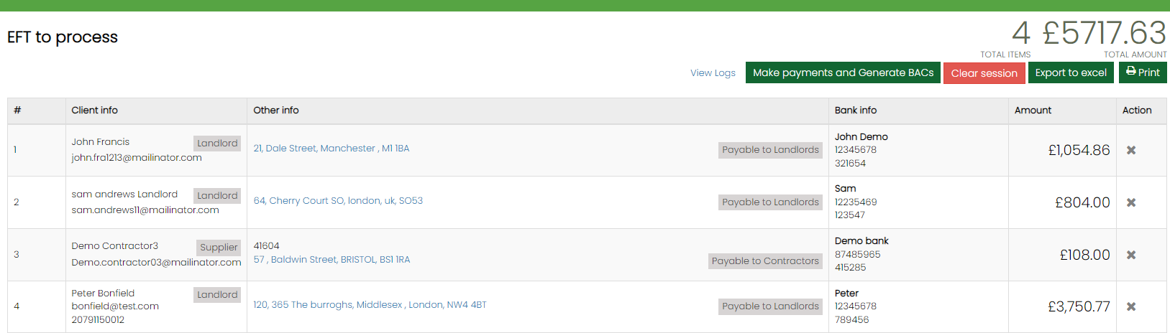

When they click on make payment button they can enter the payment method, date and any reference required to submit the payment. It will generate the BACS file with a PDF for reference, If we click on the highlighted text, It will open the BACS file which was generated. The file can be saved as .txt. Once BACS is generated they can then login to their bank account and upload the .txt file to make the payment.

Once you pay the Landlord from payable to Landlord you can map it from bank statement> Click advance search> Map the debits> Paid to Landlord > Search for the Landlords name or property address and map the transaction

Paid to Contractors

Generating BACS is similar to how we did it for landlord by ensure that you do the landlords first followed by the contractor. If there are any commissions to be taken in the contractors invoice please enter the commission first. If the client pays the contractor through agency account then it has to be separately from EFT

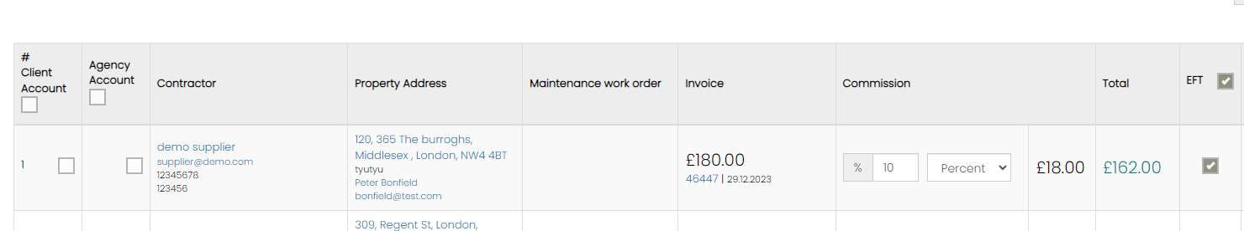

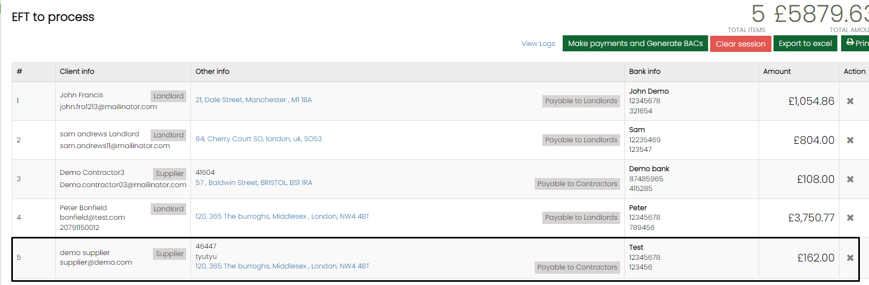

Once you pay the contractor from payable to contractor you can map it from bank statement> Click advance search> Map the debits> Paid to contractors> Search for the contractors name or property address and map the transaction

Payable to Tenant

Generating BACS is similar to how we did it for

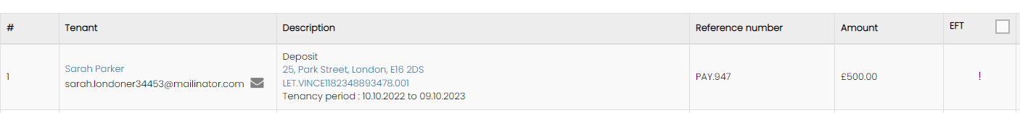

If there is not bank account added you will get an exclamation mark under EFT as shown above.

Once you pay the tenant from payable to tenant you can map it from bank statement> Click advance search> Map the debits> Paid to tenants> Search for the tenants name and map the transaction

Deposits

Deposits to be registered or transferred will get added to the deposits page under finance

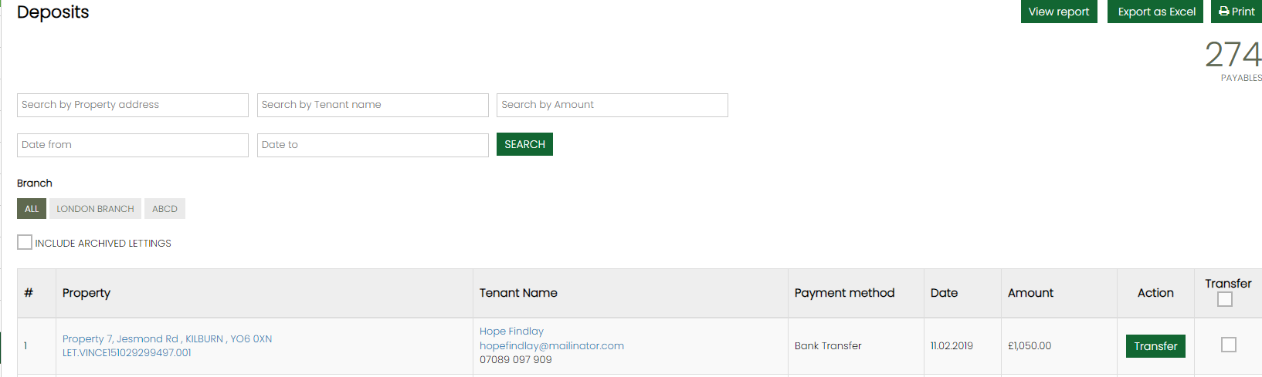

They can they click transfer to transfer the deposit to the deposit scheme. Once they transfer they can map this from bank statement> Click advance search> Map the debits> Paid to DPS

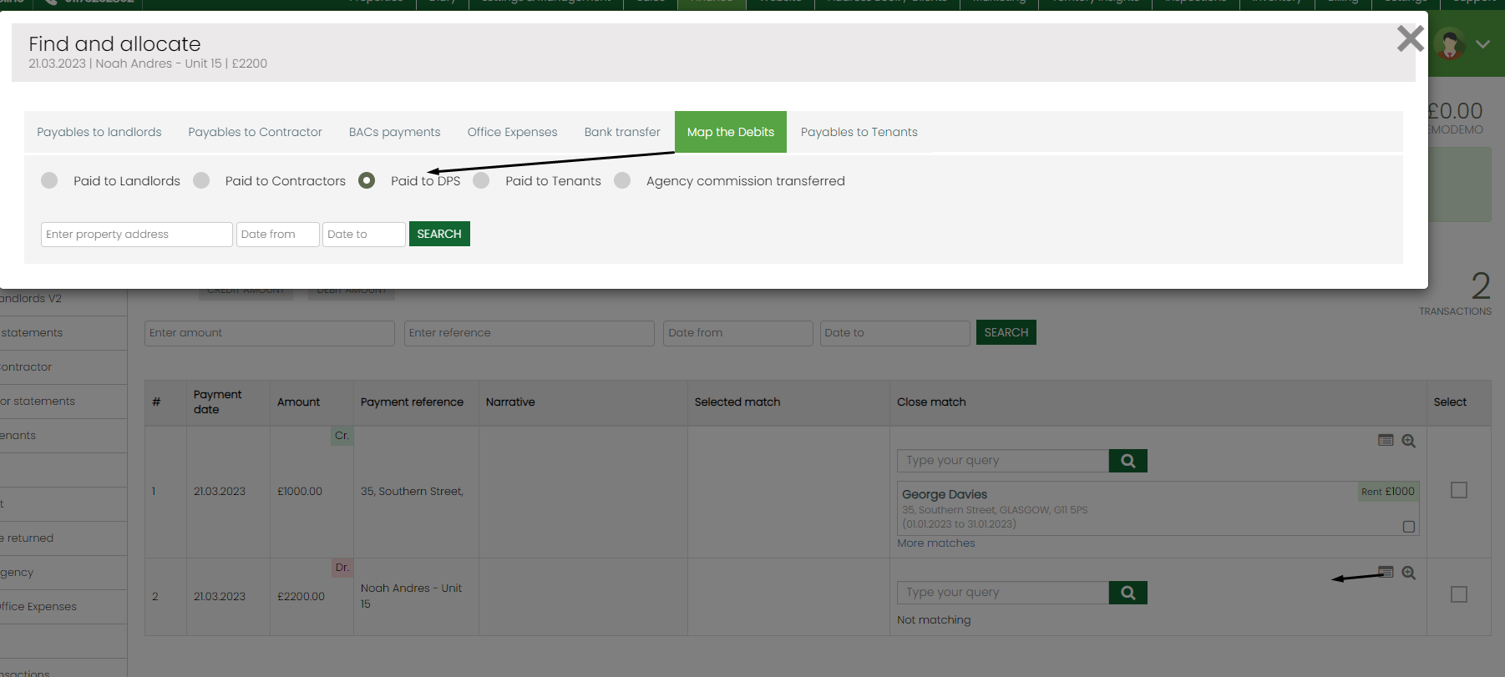

Once you click search by default you will get all the properties for which the deposit has already been transferred. You can also search or a particular property to map the deposit

Agency commission transferred

By default we will be enabling payable to agency v2 for any new clients coming in and it is recommended for our clients to use the same as this would help refresh the balance and remove filters that are not essential. For example date.
Once landlord and contractor payments are made it is advisable for the client to transfer the agency commission and close the cycle. Once transferred they can map this from bank statement> Click advance search> Map the debits> Agency commission transferred

